**PRACTICAL 02**

**AIM -**

Learning PowerPoint:

A] Create 5 slides using Microsoft PowerPoint.

B] Create a 5 - slide Canva presentation on Recycling of plastic.

C] Prepare a 2-minute video in Canva.

D] Design Flyers / Business cards for any company.

**2 [A]:**

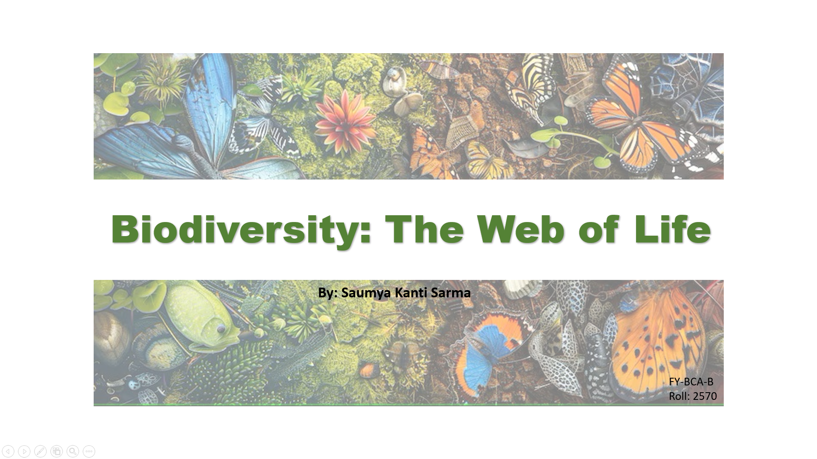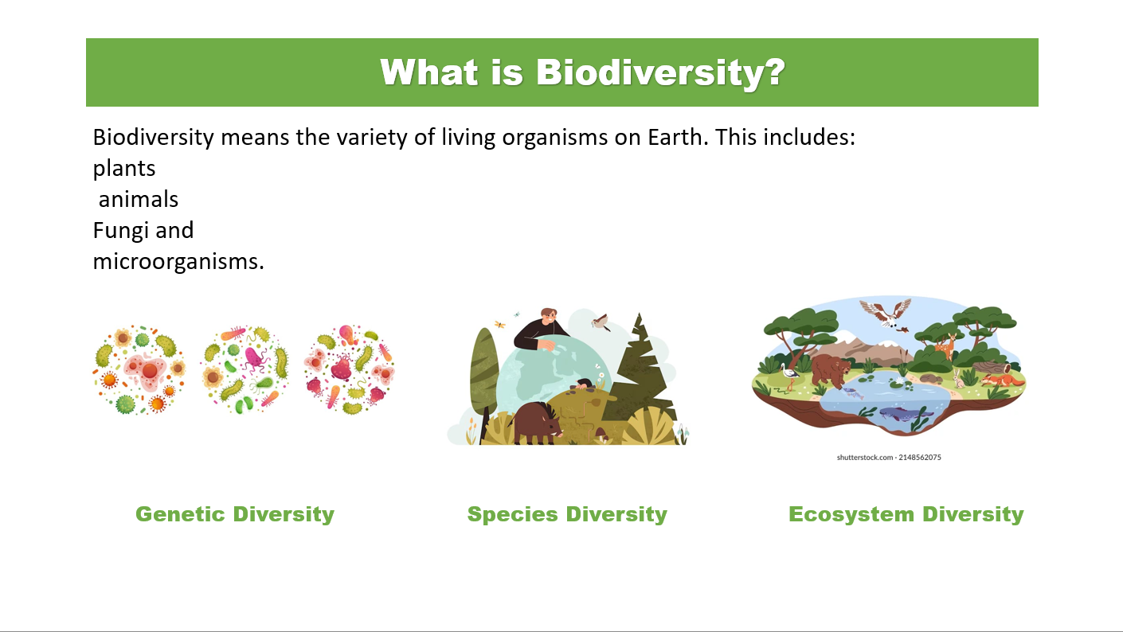

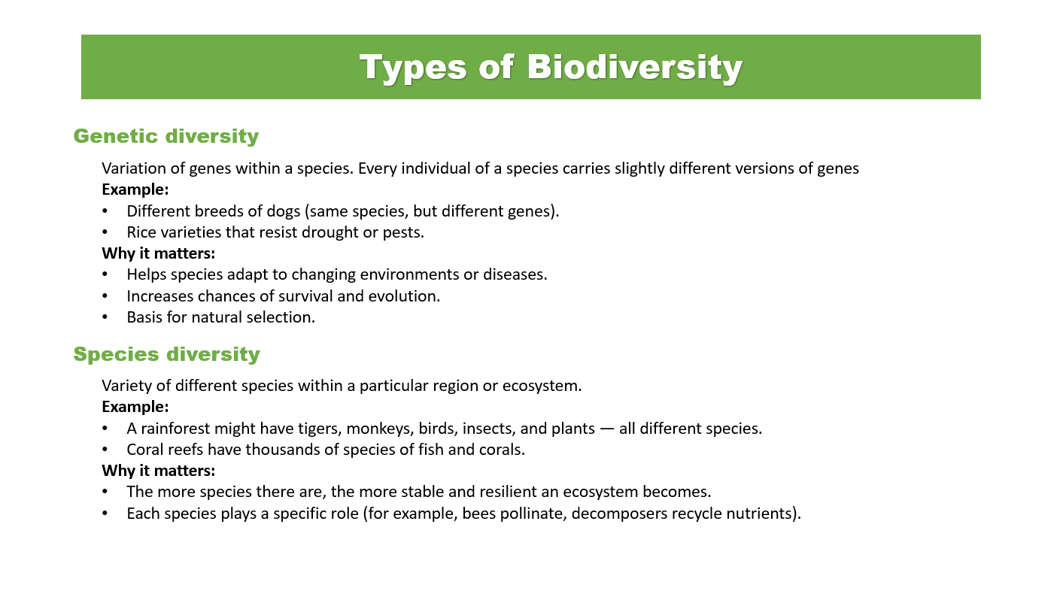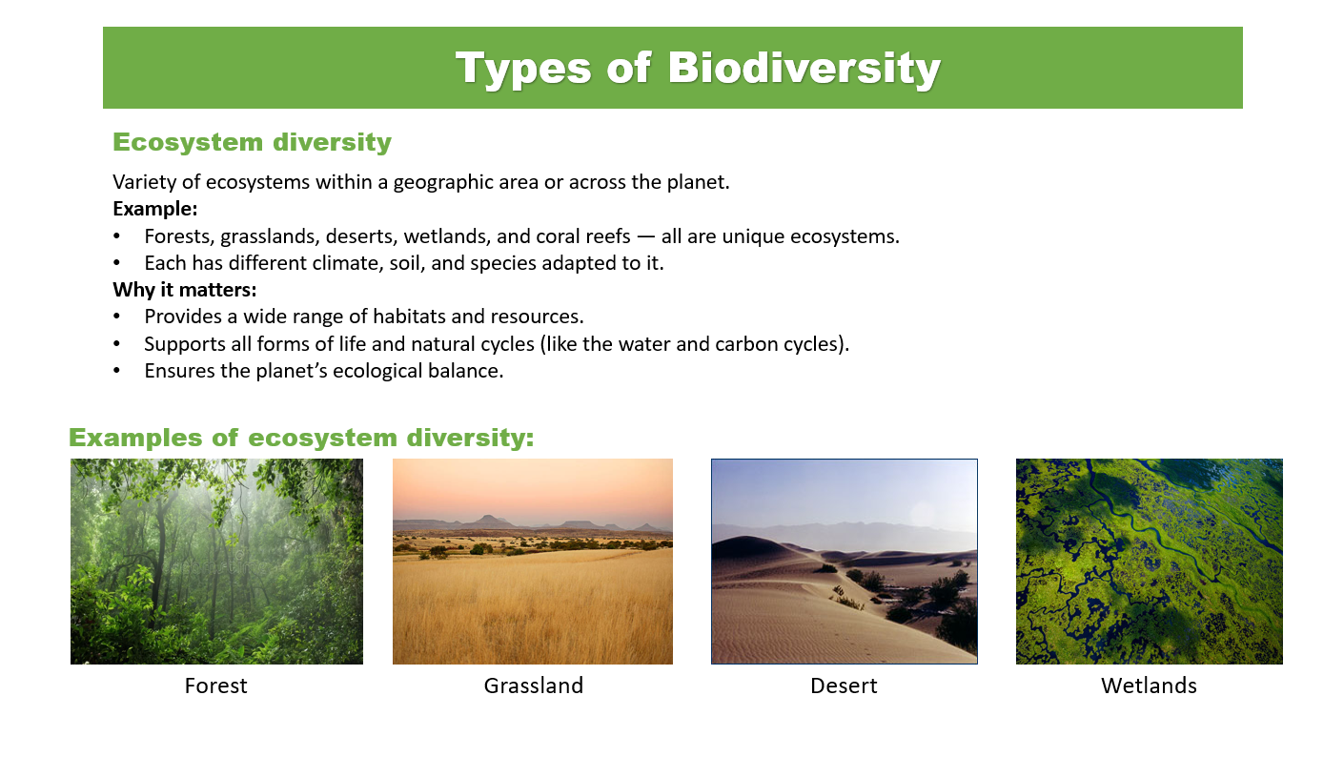

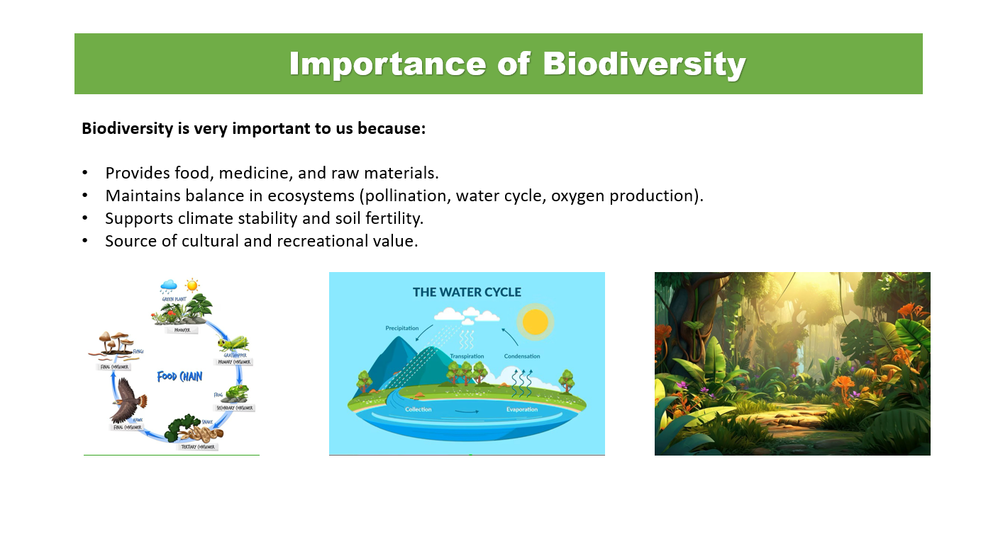

**2 [B] :**

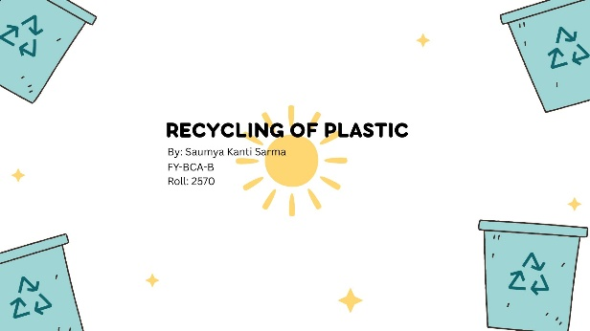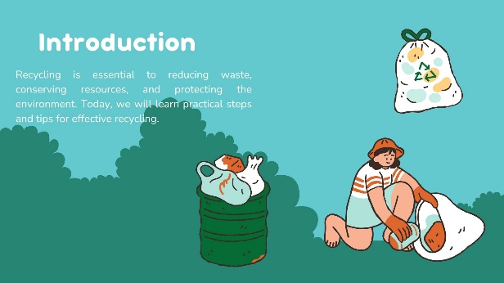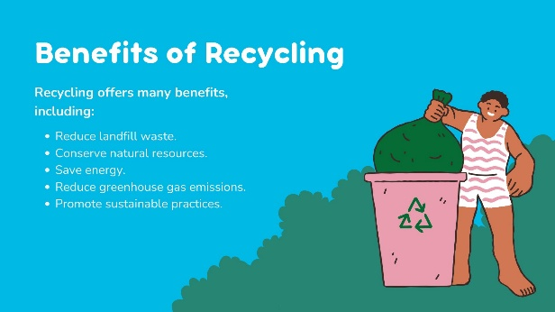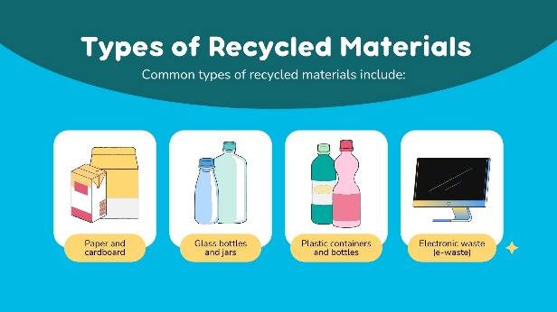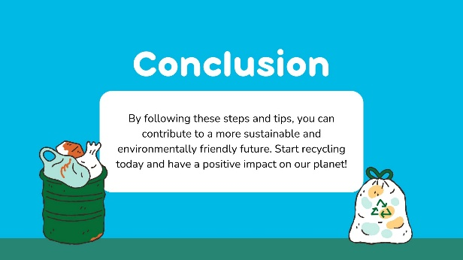

**2 [D] :**

Business card

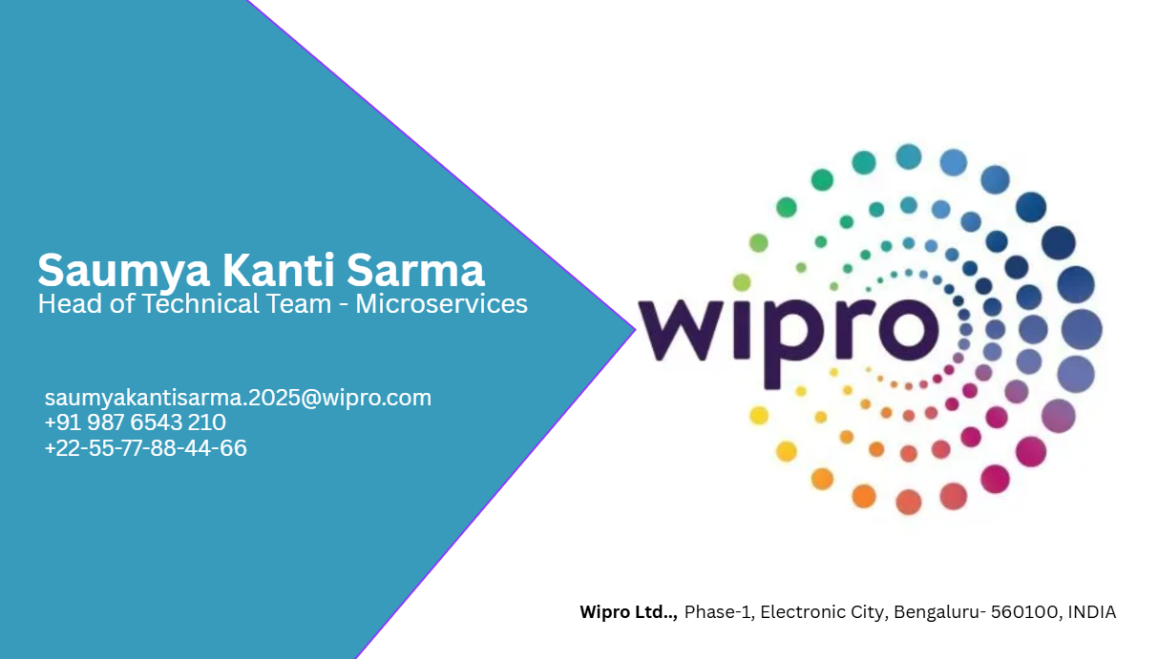

Flyer

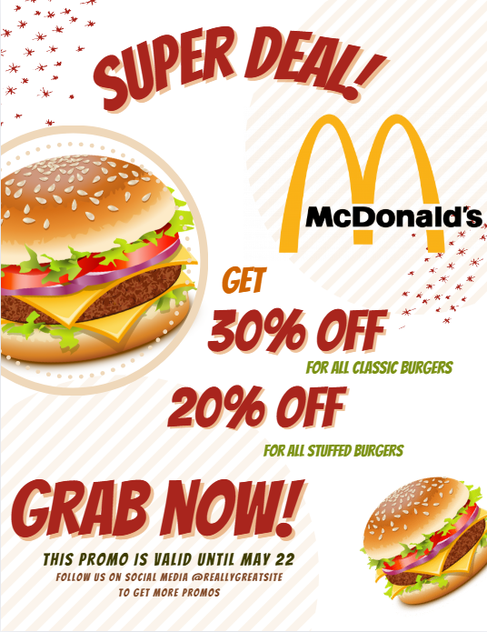

**CONCLUSION -**

Hence, we have successfully implemented powerpoint skills and made presentations using Microsoft and Canva applications. Additionally, we have also completed Business cards & flyers in Canva.